Pre Calc Name: ______________

______________ ______________
WS Assessment

Target 1
- Function Basics
- Working with Functions
- Function Domain and Range
- Equations of a Line
- Graphing Functions

HW 1 Linear Function www.deltamath.com

Evaluation function
Given function $f\left(x\right)=x^{2}+\sqrt[3]{x}+e^{2x}$. Find f (2) f (2.05) $f(\frac{2}{3})$.
(Value, Table, Function, and Manual)

Now your turn: $f\left(x\right)=x^{3}+\sqrt[3]{x+2}+e^{2x-3}$
Show at least 4 different ways for stamp

Given $f\left(x\right)=x^{2}-3x$ rewrite the following as simplified polynomial
f(-x) | f(x) + 2 | f(x+2)

Now you do: $f\left(x\right)=x^{2}+4x$
f(2x) | f(x) – 2x | f(1 – x)

Given $f\left(x\right)=x^{2}-3x$ rewrite f(x + h) as simplified polynomial

Given $f\left(x\right)=x^{2}-3x$ express $\frac{f\left(x+h\right)-f(x)}{h}$ in simplest form

Now you do.
Given $f\left(x\right)=x^{2}+4x$ express $\frac{f\left(x+h\right)-f(x)}{h}$ in simplest form

Given $f\left(x\right)=4x-2$ express $\frac{f\left(x+h\right)-f(x)}{h}$ in simplest form
Find domain and range for the following function graph
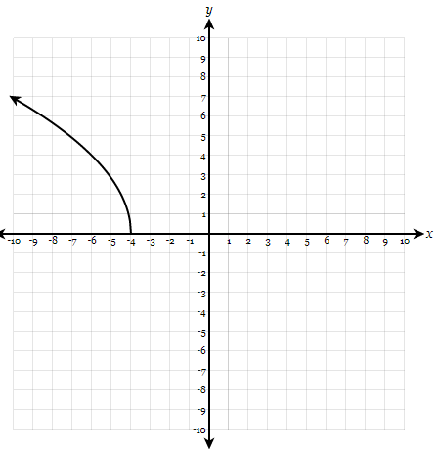 | 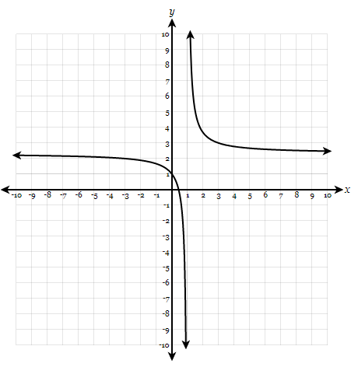 | 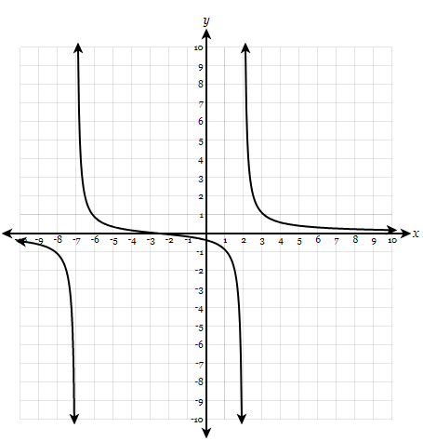

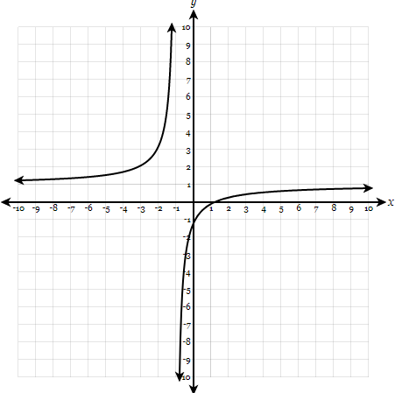 | 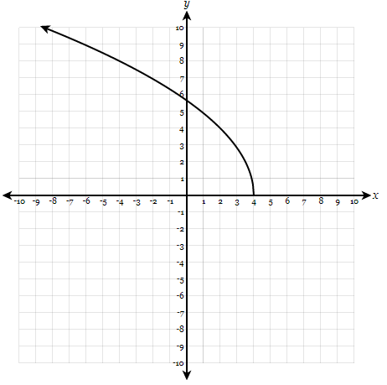 | 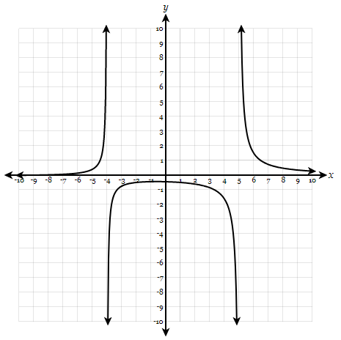

Find domain and range for the following function graph (desmos may help)
$f\left(x\right)=-3-\sqrt{-x-5}$ $f\left(x\right)=-1+\sqrt{25-x^{2}}$ $f\left(x\right)=-\left|4x+12\right|+8$

$f\left(x\right)=\frac{2x-3}{5x-15}$ $f\left(x\right)=\sqrt{x^{2}-4x-5}$ $f\left(x\right)=\frac{4x-1}{x^{2}-x-30}$

Graph this piecewise, state its domain and range show me for stamp. Sketch
$f\left(x\right)=\begin{matrix}x^{2}-5 , x<-1 \\ \sqrt{x} , 1<x<5 \\ \frac{1}{x}+8 , 6<x<17\end{matrix}$
Distance between two points $d=\sqrt{{(x_{2}-x_{1})}^{2}+{(y_{2}-y_{1})}^{2}}$
Midpoint formula $x=\frac{x_{1}+x_{2}}{2},y=\frac{y_{1}+y_{2}}{2}$
Find the distance and midpoint of the segment between A(-4, -3) and B(1, 1)

Find the distance from the point P(-3, 5) to the midpoint of the line segment between A(5, -2) and B(1, 6)

Use the distance formula to find an equation of the perpendicular bisector of the line segment between the points (4, 3) and (-2, 5)

Find the coordinates of the points one-third and two-thirds of the way from a = 2 to b = 8 on a number line

Find the coordinates of the points one-third and two-thirds of the way from the point (1, 2) to the point (7, 11) in the coordinate plane.

Linear equations
The slope of a line through the points (x₁, y₁) and (x₂, y₂) is given by $m=\frac{y_{2}-y_{1}}{x_{2}-x_{1}}$
There are three forms that you need to master
1. Point-Slope Form: The line through the point (x₁, y₁) with slope m has equation
y – y₁ = m(x - x₁)
2. Slope-Intercept Form: The line with slope m and y-intercept b has equation
y = mx + b.
3. Standard form
ax + by = c (where a > 0)

Two lines with slopes m₁ and m₂ are parallel iff m₁ = m₂ (iff = if and only if);
and perpendicular iff (m₁)(₍m₂) = -1

Write equation of the line which passes through the point (8, - 2) and has y-intercept 5.
in Point-Slope form, Slope-Intercept form and Standard form. Hint: Find slope first

Write equation of the line which passes through the point (2, -6) and is parallel to the line
4x – 3y = 24 in Point-Slope form, Slope-Intercept form and Standard form (ax + by = c)

Write an equation of the line which passes through the point (-4, 3) and is perpendicular to the line 2x – 5y = 20 in Point-Slope form, Slope-Intercept form and Standard form (ax + by = c)

Now you do. Given point P(____, _____) you fill in. Write the equation of line L parallel to the line 2x – 5y = 10 and pass thru P in a form of your choice. Then write the equation of another line M perpendicular to 2x – 5y = 10 in a different form. Show me graph of three lines for stamp.

Target 1 Assessment

Given $f\left(x\right)={2x}^{2}+2x$
- Find $f(\sqrt{3})$
- Write f (x + 2) – 2 in simplest polynomial form
- Express $\frac{f\left(x+h\right)-f(x)}{h}$ in simplest form
- Graph f (x+2) – 2 for the domain [-5, 5] show me for stamp. Sketch and state the domain and range

Given point A(2, 3) and B(7, 6).
- Find midpoint M
- Write the equation of the line perpendicular to AB and pass thru midpoint M
- Find the point P on this perpendicular line such that PM = AB

